1. 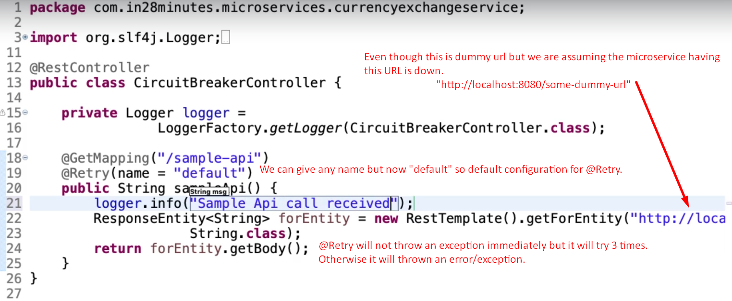
2. 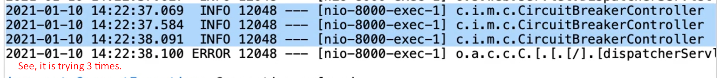
3. 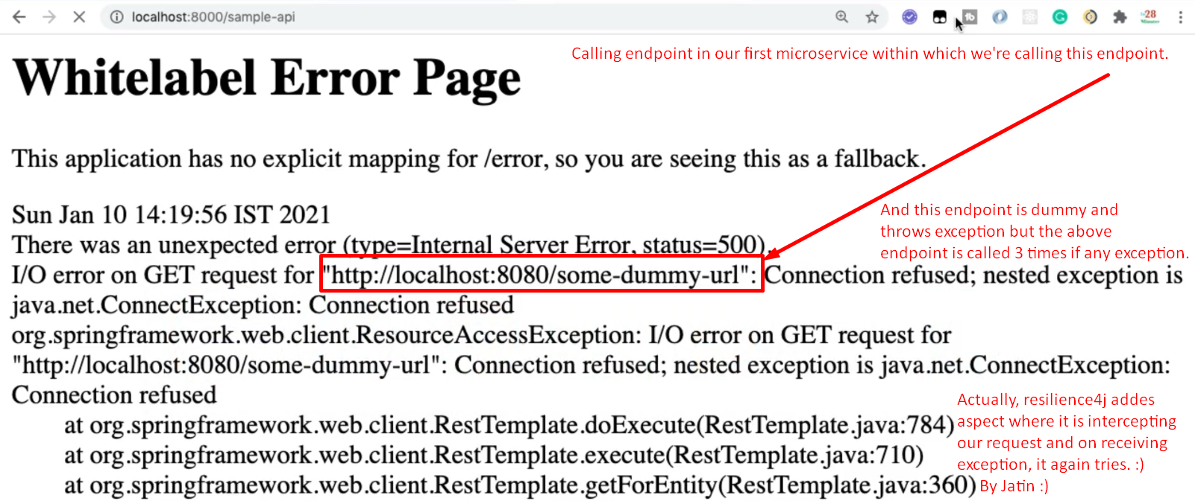
4. By default, 3 retry but how to configure a specific # of retries.
5. 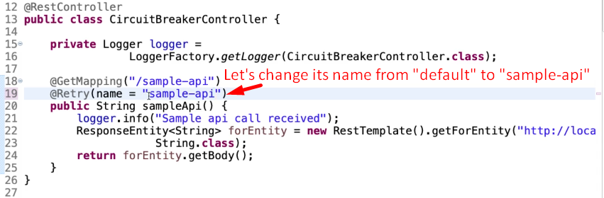
6. 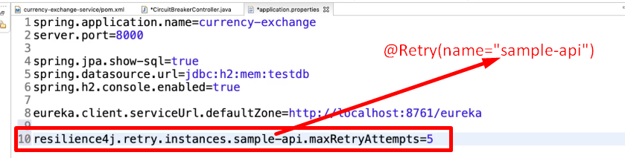
7. 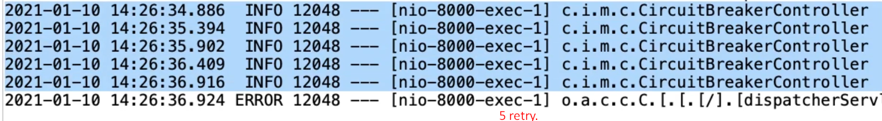
8. 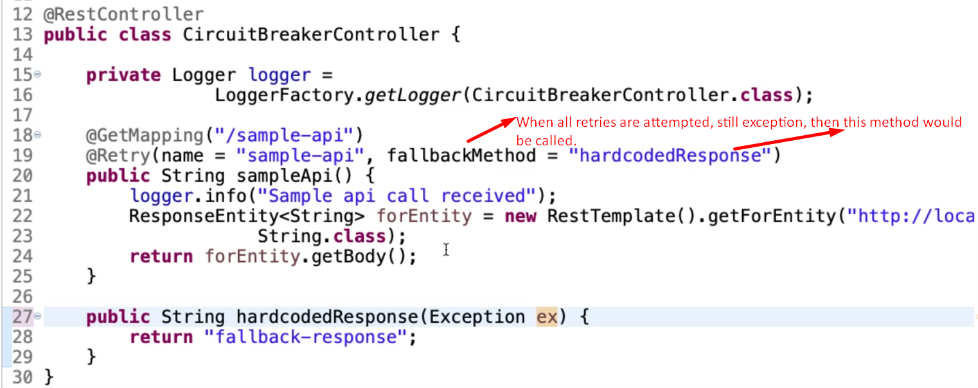
9. 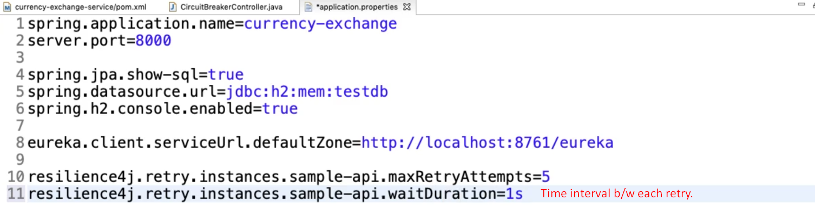
10. 
11. 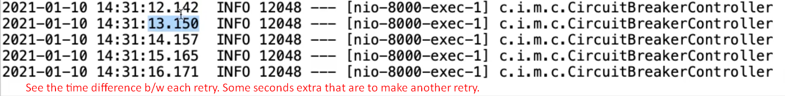  
    Sorry: Not some extra seconds but some extra milliseconds. ☺
12. 